INTRODUCTION

Malaria is one of the leading causes of infectious disease worldwide, with between 154 and 289 million people being infected by it in 2010 alone. Of these people, around 660,000 of them died from the disease.[1] Malaria is caused by a single-cell parasite (genus *Plasmodium*) and is transmitted to humans via mosquitoes (genus *Anopheles*). The parasite’s success in a mosquito host depends on environmental factors such as temperature and humidity; the parasite thrives in a host when temperatures are higher, and mosquitoes thrive when the temperature is in the right range and there is enough water present for viable eggs.[2] The transmission of malaria from mosquitoes to humans is complex and is related to both environmental and socioeconomic factors. Parham and Michael[3] determined that the transmission of malaria is optimized around 32-33 degrees Celsius. Mosquitoes do not thrive as well in temperatures both below and above this temperature, which prevents more mosquitoes from living long enough for the parasite to complete its life cycle. This temperature range has been debated, though, with another study done by Gillioli and Mariani[4] concluding that there is a bell-shaped distribution of mosquito population that peaked at 24-25 degrees Celsius; this was supported by a study conducted by Mordecai *et al*.[5] The study that reported higher ideal temperatures analyzed more recent data, while the studies that found lower ideal temperatures included data from farther back. The discrepancy could be related to global warming and increases in baseline temperatures, or the first study just had fewer data and only looked at recent years where temperature has been high.

A graphical analysis of malaria and environmental data from Mozambique was conducted using R. Because of known environmental factors influencing malaria transmission and endemics, the cycle of malaria cases was compared to the cycles of temperature and rainfall. The data were from 2010-2016. There were some data from 2017, but a complete years’ worth of data was not available for 2017 and was thus excluded from some analyses. Cases were counted each week and analyzed as cases per thousand (CPT) for children under the age of 5. This was calculated first at the province level and then aggregated over entire districts of the country. Temperature was averaged over each week by province and district. Rainfall was aggregated over each week by province and district. Due to meteorological systems and the life cycle of mosquitoes, malaria cases increase a certain amount of time after rainfall and during ideal temperatures. Because of this, one primary question of interest was what the optimum lag time between CPT and total rainfall, and CPT and average temperature were to predict future malaria case numbers. Other questions considered were whether how any of the variables of interest vary across the country of Mozambique, and how they vary across time. Additionally, the difference in CPT between 2010 and 2016 were examined.

ANALYSIS

First, optimum lag times were examined using the ccf function of the Stats package (found in base R). This allows us to check each potential lag time (in weeks) between the number of CPT and the predictor of interest. It was found that CPT is most correlated with total rainfall when there is a lag of 4 weeks (), and that CPT was most correlated with average temperature when there is a lag of 16 weeks (). Correlations can be found in Table 1. After graphing CPT and total rainfall with a 4-week lag, we can see that the peaks of the two variables line up in Figure 1; this is also apparent with average temperature with a 16-week lag and CPT in Figure 1.

|  |  |  |  |  |
| --- | --- | --- | --- | --- |
|  | 2 wk Lag | 4 wk Lag | 8 wk Lag | 16 wk Lag |
| Total RAIN: CPT Corr | 0.0820842 | 0.1196690 | 0.1085809 | 0.0630054 |
| Average Temp: CPT Corr | 0.0424018 | 0.0715984 | 0.1498911 | 0.2100981 |

Table 1: Correlations between lag times of predictors and CPT. CPT is most correlated with a 4-week lag in total rain and a 16-week lag in average temperature.

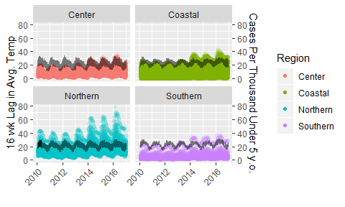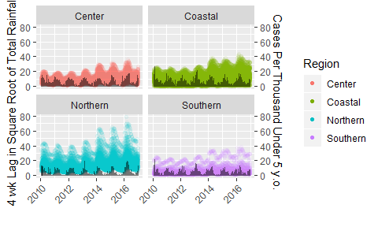Figure 1: Comparing CPT to total rainfall with a 4-week lag and average temperature with a 16-week lag. The square root of total rainfall was used to the data would visually line up.

Next, total rainfall on its own was analyzed. Based on histograms of total rainfall by region for each year, we can see that from 2010 to 2014 the Coastal region had the most rain, but in 2015 to 2016 the Central region experienced more rain. This can be seen in Figure 2. Total rainfall was around 10,000 mm for most regions until 2016, where 3 out of the 4 regions had over 20,000 mm.

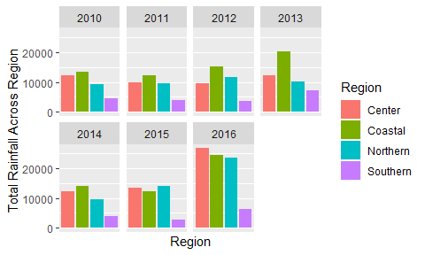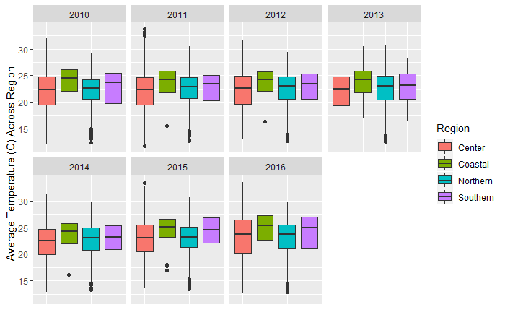

Figure 2: Total rainfall by region of 2010-2016. The Southern and Northern regions consistently experienced less rain than the Central and Coastal regions. In recent years it appears that the Central region has been experiencing more rain than the Coastal Region. Average temperature by region for 2010-2016. Average temperature seems consistent, with the Central region experiencing the most extremes and Southern region experiencing the least variable temperatures.

Maps of Mozambique can be used to see how temperature, rainfall, and CPT vary across the country. In Figures 3 and 4 we can compare 2010 to 2016. In Figure 3, the country seems to have experienced less rainfall than 2016 across the country after examining the color scales. Countries that were experiencing high levels of rain in 2010 (>500 mm) were seeing more than 1,000 mm of rain in 2016. Average temperature seems to have stayed fairly constant between 2010 and 2016, except for a small increase along the southeast coast. Districts that reported average temperatures of 22-24 C in 2010 experienced average temperatures of 24-26 C in 2016. Districts that reported higher CPT values in 2010 were still the districts reporting the highest CPT in 2016. The absolute value of this has increased, though. The districts reporting highest CPT in 2010 had between 25 and 35 cases per thousand, while in 2016 these districts had 40 to 60 cases per thousand. There are no noticeable changes of districts reporting low CPT in 2010 then high in 2016, or vice versa.

Figure 5 shows the change in cases per thousand between 2016 and 2010. Based on graphs previously described, it should be expected that most districts saw an increase in CPT. Dark green indicates a less-than-zero value, or a decrease in cases per thousand, but it does not appear that any districts are this color in Figure 5. Most districts experienced a mild increase in cases per thousand (between 0 and 5). The northern part of the country saw the greatest increase in cases per thousand, with many districts increasing by 10-20 CPT and one increasing by more than 20 CPT.

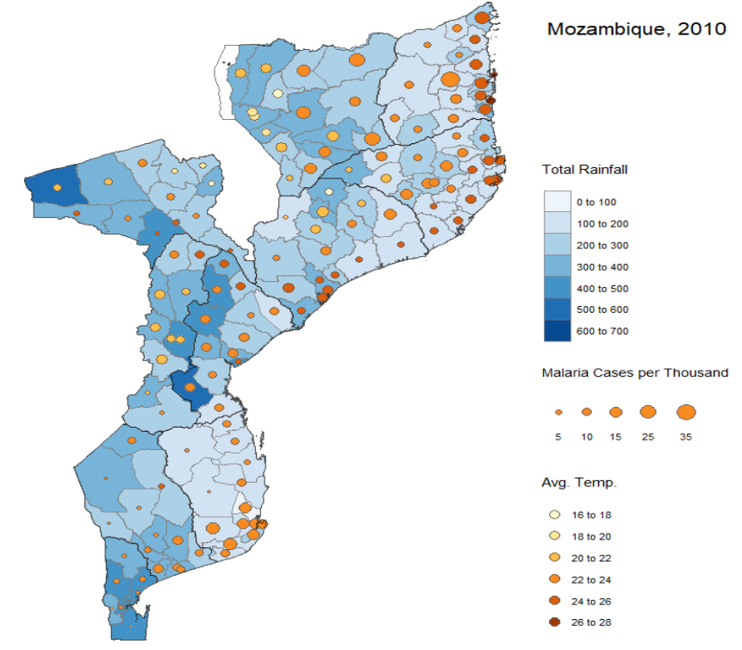

Figure 3: Total rainfall, CPT, and average temperature across Mozambique in 2010.

CONCLUSIONS

CPT is most correlated with total rainfall from 4 weeks prior to the week that any CPT value was reported. CPT is most correlated with average temperature from 16 weeks prior to the week that any CPT value was reported. This is due to the cyclical nature of both weather and mosquito and malaria cycles. Rain and temperature affect mosquito survival, and four or so weeks later the mosquitoes can infect people. A week to two weeks from infection a person is likely to go to a clinic and is diagnosed with malaria. All factors contribute to the lag between cases of malaria and environmental factors.

Temperature is consistent across districts and regions from 2010-2016. Districts are generally receiving more rainfall over the years, with a huge increase between 2015 and 2016 in total rainfall.

All districts saw an increase in CPT reported between 2010 to 2016, with the majority only increasing by about 5. A few districts saw large increases of greater than 10 CPT between 2010 and 2016.

Further analysis could be done with intervention data and to monitor the influence of preventative materials such as bed nets over the years. Generalized linear mixed models could be fit to the data to predict CPT values in the future; this model should be used due to the non-linearity of the outcome data and repeated measures over the same districts. Additional variables related to socioeconomic status should also be examined for relationships with malaria cases since previous literature has shown that can influence the spread of malaria.

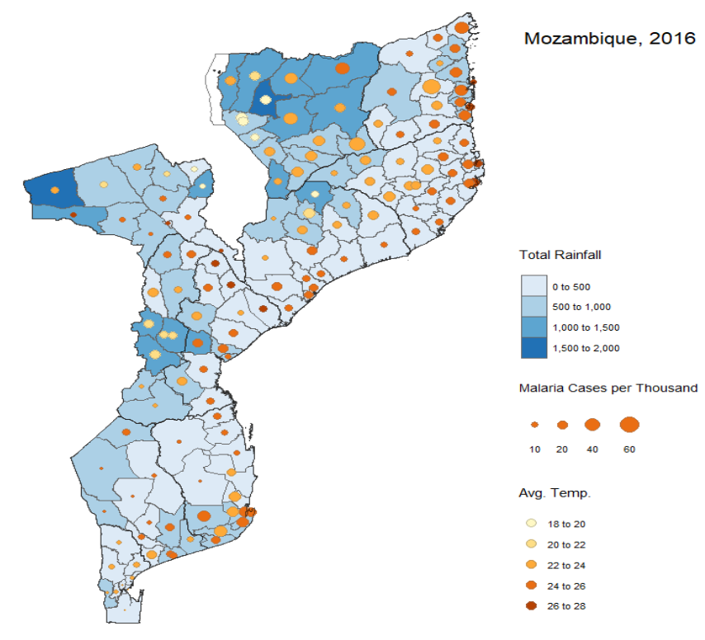

Figure 4: Total rainfall, CPT, and average temperature across Mozambique in 2016.

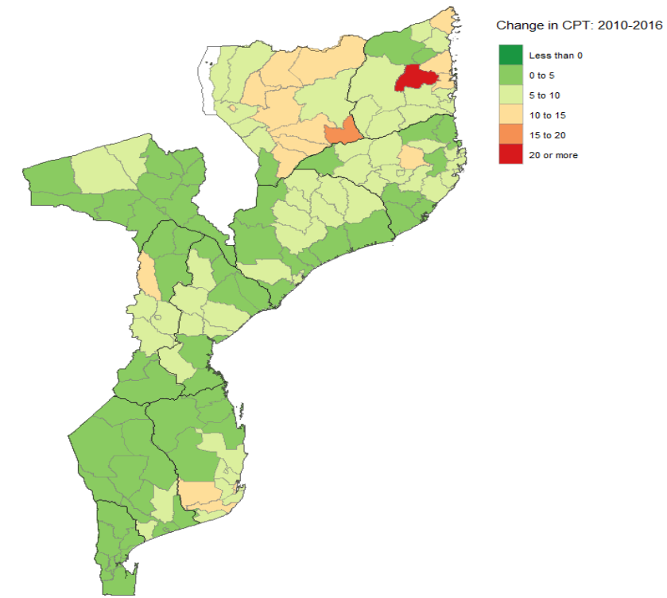

Figure 5: Change in CPT from 2010 to 2016. All countries saw a positive change or had higher CPT in 2016 than 2010.

REFERENCES

Gilioli, Gianni, and Luigi Mariani. “Sensitivity of Anopheles Gambiae Population Dynamics to Meteo-Hydrological Variability: A Mechanistic Approach.” *Malaria Journal* 10, no. 1 (October 10, 2011): 294. https://doi.org/10.1186/1475-2875-10-294.

Mordecai, Erin A., Krijn P. Paaijmans, Leah R. Johnson, Christian Balzer, Tal Ben‐Horin, Emily de Moor, Amy McNally, et al. “Optimal Temperature for Malaria Transmission Is Dramatically Lower than Previously Predicted.” *Ecology Letters* 16, no. 1 (January 1, 2013): 22–30. https://doi.org/10.1111/ele.12015.

Organization, World Health. *World Malaria Report 2014*. World Health Organization, 2015.

Parham Paul Edward, and Michael Edwin. “Modeling the Effects of Weather and Climate Change on Malaria Transmission.” *Environmental Health Perspectives* 118, no. 5 (May 1, 2010): 620–26. https://doi.org/10.1289/ehp.0901256.

Prevention, CDC-Centers for Disease Control and. “CDC - Malaria - About Malaria - Biology - Mosquitoes - Anopheles Mosquitoes,” March 28, 2017. https://www.cdc.gov/malaria/about/biology/mosquitoes/index.html.

Erich Neuwirth (2014). RColorBrewer: ColorBrewer Palettes. R package version 1.1-2. https://CRAN.R-project.org/package=RColorBrewer

Tennekes M (2018). “tmap: Thematic Maps in R.” _Journal of Statistical Software_, *84*(6), 1-39. doi: 10.18637/jss.v084.i06 (URL: http://doi.org/10.18637/jss.v084.i06).

H. Wickham. ggplot2: Elegant Graphics for Data Analysis. Springer-Verlag New York, 2016.

Hadley Wickham, Romain François, Lionel Henry and Kirill Müller (2018). dplyr: A Grammar of Data Manipulation. R package version 0.7.6. https://CRAN.R-project.org/package=dplyr

Pebesma, E.J., R.S. Bivand, 2005. Classes and methods for spatial data in R. R News 5 (2), https://cran.r-project.org/doc/Rnews/.

Roger S. Bivand, Edzer Pebesma, Virgilio Gomez-Rubio, 2013. Applied spatial data analysis with R, Second edition. Springer, NY. http://www.asdar-book.org/

Ross Ihaka, Paul Murrell, Kurt Hornik, Jason C. Fisher, Achim Zeileis (2016). colorspace: Color Space Manipulation. R package version 1.3-2. URL https://CRAN.R-project.org/package=colorspace

Yihui Xie (2018). knitr: A General-Purpose Package for Dynamic Report Generation in R. R package version 1.20.

1. Organization, *World Malaria Report 2014*.
2. Prevention, “CDC - Malaria - About Malaria - Biology - Mosquitoes - Anopheles Mosquitoes.”
3. Parham Paul Edward and Michael Edwin, “Modeling the Effects of Weather and Climate Change on Malaria Transmission.”
4. Gilioli and Mariani, “Sensitivity of Anopheles Gambiae Population Dynamics to Meteo-Hydrological Variability.”
5. Mordecai et al., “Optimal Temperature for Malaria Transmission Is Dramatically Lower than Previously Predicted.”